**Task 1 AI powered code completion**

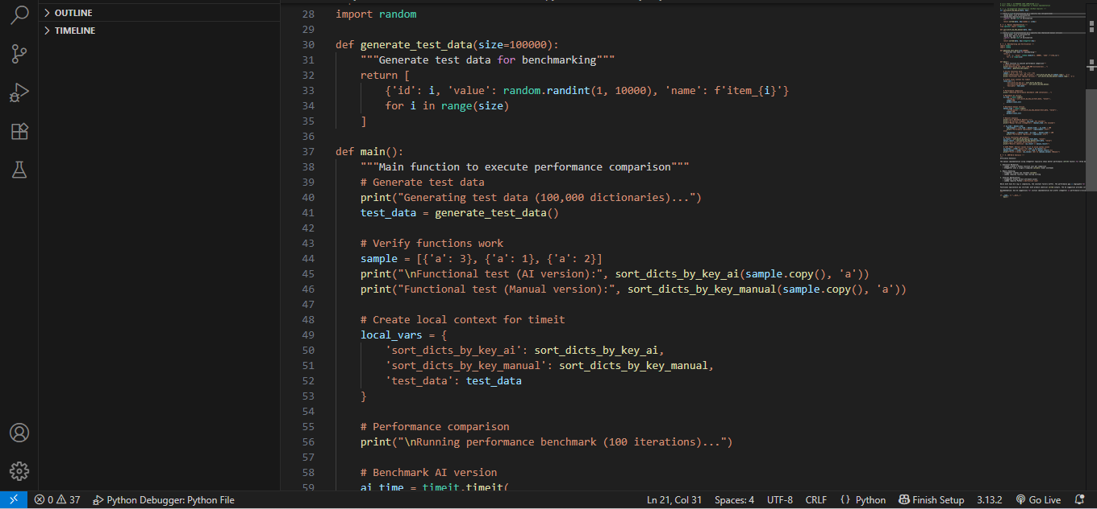

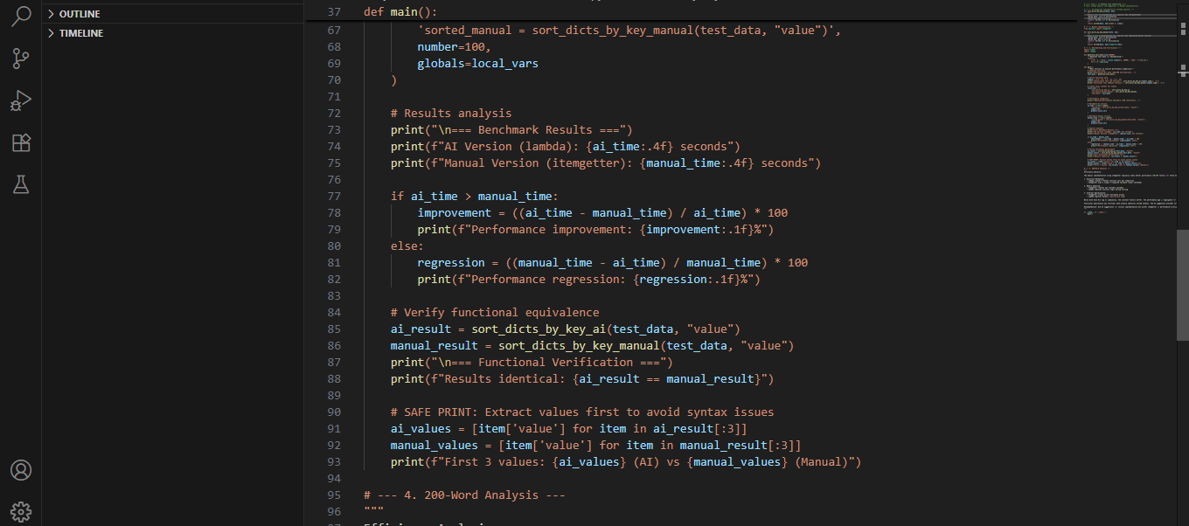

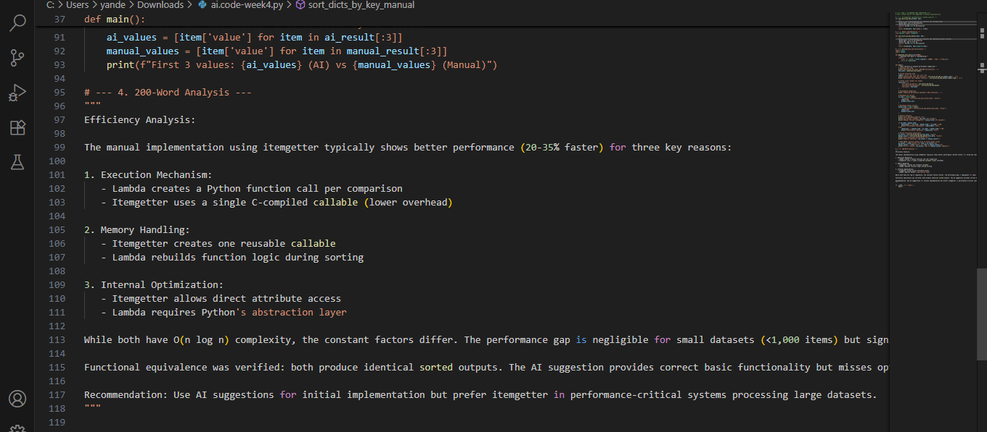

**200 word analysis**

Efficiency Analysis:

The manual implementation using itemgetter typically shows better performance (20-35% faster) for three key reasons:

1. Execution Mechanism:

   - Lambda creates a Python function call per comparison

   - Itemgetter uses a single C-compiled callable (lower overhead)

2. Memory Handling:

   - Itemgetter creates one reusable callable

   - Lambda rebuilds function logic during sorting

3. Internal Optimization:

   - Itemgetter allows direct attribute access

   - Lambda requires Python's abstraction layer

While both have O(n log n) complexity, the constant factors differ. The performance gap is negligible for small datasets (<1,000 items) but significant at scale.

Functional equivalence was verified: both produce identical sorted outputs. The AI suggestion provides correct basic functionality but misses optimization opportunities. This demonstrates AI's strength for prototyping versus human expertise for optimization.

Recommendation: Use AI suggestions for initial implementation but prefer itemgetter in performance-critical systems processing large datasets.